*

HISTORY OF THE

BLUEBILL AIRCRAFT PAINTING

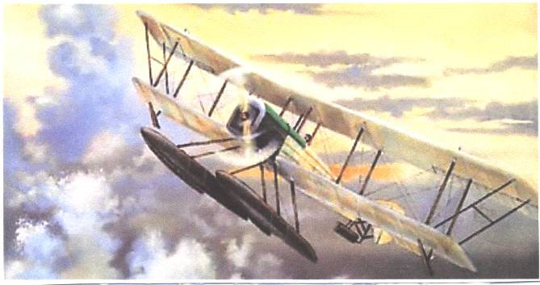

PATSY ANN III, A WORLD WAR II B-17, CALL SIGN “BLONDIE F FOR FOX”, AND THE PAINTING OF THIS FIRST BOEING AIRPLANE NAMED BLUEBILL, A SYMBOL OF THE BOEING RETIREE PROGRAM, IS A STORY OF HISTORIC AND ALMOST MYTHICAL CONNECTIONS.

Two major events critical to the story of the Bluebill Painting are:

(1) Why the Boeing Retiree Volunteer Program is named Bluebill;

and

(2) How the shoot down of Patsy Ann III, a Boeing B-17, over Munster, Germany on 10 October 1943, is key to a chain of events. Those events resulted in this painting of the first Boeing aircraft named Bluebill.

Was the inspirational painting of the historic Boeing Bluebill aircraft symbolizing vision, courage and excellence a result of chance? Or, does this sequence of events demand another answer? This story will provide an insight. The reader must make the call.

WHERE DID THE NAME BLUEBILL FOR THE BOEING RETIREE VOLUNTEER PROGRAM COME FROM?

Without the name Bluebill for the Boeing Retiree Volunteer Program there would be no story. The name can be attributed to the dogged persistence and knowledge of Boeing history by one of the founders of the Program, the late Lee Collegeman. Lee was a World War II US Navy Officer, a Boeing retiree, and a critical player in the saga of the Bluebill organization and thus this Bluebill painting.

In September of 1994, under the guidance of Boeing and with their support, the Boeing Retiree Volunteer Program was born. Because the program was founded by retired Boeing professionals having multiple skills used to build military and commercial aircraft, space and rocket systems, the birth was the result of a rigorous process. There was little left to chance.

By December 1994, the group of 30 men and women, 29 Boeing retirees, spouses and one Boeing program manager had reached the point where the retiree volunteer program was ready for a name. Name choice was not an easy task. Many names were suggested, including BRVP, an obvious acronym, BRAVO and others. Frustration was growing, for no name had captured the spirit and purpose of the organization.

Lee took over. He stated he had the right name to symbolize this new organization. His name would give the new organization historical perspective. He said the Retiree Program would be named after the first Boeing airplane, BLUEBILL! What is a Bluebill? No one but Lee knew what the name Bluebill stood for or the historical significance. Most of the group thought it was a duck. Everyone, except Lee, seriously questioned how such a name would capture the attention of the community. Lee persisted by saying that the first Boeing airplane, like the first Boeing Retiree Volunteer Program, was the product of courage, dedication, professionalism, smarts, creativity and persistence. Both the first and the latter day Bluebill represented vision of the future. As a matter of fact, the first Boeing Retiree Volunteer Program pamphlet stressed: “Just as the historic Bluebill was the first aircraft of a company that helps bring people around the world closer together, today’s Bluebills are uniting Boeing retirees to improve the quality of life in our communities.” Lee Collegeman in essence said that tomorrow the Bluebill would be a household word in the Puget Sound community. He won the day and the name was accepted.

Lee had foresight and he was right. The latter day Bluebills share their skills, experience, enthusiasm, and their professionalism, to have fun and to give them relevance by helping their community.

Bluebill volunteers are today, ten years later, a household word in the Puget Sound community.

Now you know the background of and why the Bluebill name.

THE ROADMAP LEADING TO THIS BLUEBILL AIRCRAFT PAINTING HAS HISTORIC AND UNCOMMON CONNECTIONS.

The story of this Bluebill painting sounds like fiction but it is fact. This fascinating story starts 28 years after the birth of the Bluebill, the first Boeing airplane. The curtain goes up and on stage is a flak, fighter, bomber, terror and courage filled sky over Munster Germany. The time and date was mid afternoon of 10 October 1943.

This story has a beginning but no ending.

Simply put, had a Boeing B-17 named Patsy Ann III not been shot down that afternoon over Germany, there would be no Bluebill painting. Had there been a different crew aboard Patsy Ann III, there would be no Bluebill painting. There was an improbable alignment of circumstances that afternoon and in the hours, days and years to follow, making this painting possible 53 years later. There is a clear linkage.

There was nothing unique about Patsy Ann III. Her call sign, “Blondie F for Fox”, sounded fresh and young, but in fact, she was a tired and much used B-17. She had scars. The crew had inherited Patsy Ann III and gave up a new B-17 in the process. The original pilot of Patsy Ann III was Colonel Bob Cozens, Squadron Commander of the 95th Bomb Group at Horham, England. The B-17 was named by Colonel Cozens in England in early 1943 for a charming lady, his wife, Pat. Colonel Cozens and wife Pat today live in Southern California.

Like so many 8th Air Force bombers, Patsy Ann III flew out of one of the many US Army Air Corps Bases that dotted the English countryside. The crew flew Patsy Ann III from a base near Horham in East Anglia. They were a part of the 95th Bomb Group, the 334th Squadron.

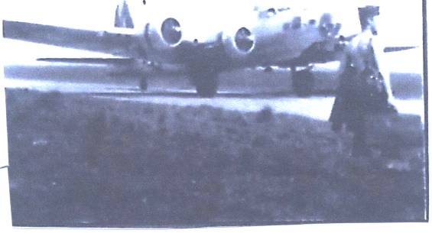

8th Air Force B-17 at Barth, Germany to airlift American POWs to freedom in May 1945

If you have seen the Great War movie “Twelve O’clock High,” you
have seen the equipment, the airplanes, the buildings, the war fighters and felt the rush of adrenalin associated with the accurate portrayal of a World War II bomber base in England. Horham was no different from most except she had a concrete runway.

Patsy Ann III had a crew of ten brave American young men that October morning. All were critical to the mission but only two play a leading role in the saga of this Bluebill painting.

The two were 21- year old copilot, “old man “ Fred Kennie and the young bombardier from Salt Lake City, 19- year old Phil Janney. Kennie, Janney and their fellow aircrew were scared, fatigued but dedicated to flying
the mission and returning alive. Almost no aircrews from their unit
completed 25 missions and a ticket home.

LT. COLONEL PHIL JANNEY
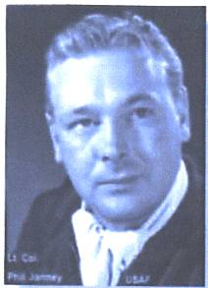

US Air Force jet fighter pilot, the bombardier of Patsy Ann III and painter of the Bluebill Aircraft.

A gambler would never make a bet with Patsy Ann III’s odds of survival at a Reno gambling table.

As Phil Janney tells the story of Patsy Ann III, like so many B-17 crews, they had been flown to absolute exhaustion but they did not waver.

These young American aircrews truly were in the front row of America’s greatest generation, only they did not know it at the time. Tragically, many never found out.

An article in the San Diego Union Tribune by Dick Growald about Fred Kennie, Patsy Ann III’s copilot, provides insight into a series of events that made this Bluebill painting possible. Many of his story highlights about copilot Fred Kennie are used in this Bluebill story. However, Growald did not know about this Bluebill painting because the article was written before the painting was created.

Patsy Ann III on 10 October 1943 was on her third daylight mission in three days. This crew of which Kennie and Janney were a part had seven missions on Patsy Ann III fatigued air frame. She was tired and patched up from damage taken during a previous mission. But the old, by combat stress, B-17 was ready to go back to war. To quote Kennie, “Patsy Ann III had flown the “Purple Heart” corner, the low tail end of the U.S. bomber formation. It had the scars to prove it.”

Their formation this October day was composed of 300 bombers. The target was Munster, Germany. Daylight mission losses without long range fighter escort had been very high. All American aircrews understood the risk.

As a crew member what would be your “pucker factor” as Patsy Ann III’s engines were revved up prior to take off?

After reaching Munster, Patsy Ann III’s target for the day, she was hit by anti aircraft and fighter aircraft fire. Janney did not know what caused the damage to Patsy Ann III because there was too much smoke.

Janney put on his parachute.

During the attack the Tail Gunner had his foot shot off. He bailed out so German doctors could save his life. He survived.

During the battle Janney shot the canopy off a Folke-Wulf 190. And, through all the confusion he was able to put bombs on target. Patsy Ann III was breaking into a turn to leave the target when they were hit.

Patsy Ann III was in trouble. She had received mortal damage. Fire raged and the hydraulic controls were gone. Patsy Ann III started a slow but ever increasing and fatal spin.

The old Boeing B-17 would not return to East Anglia and the shelter of the base at Horham. If the crew did not bail out before the spin became too tight they would never live another day. Five did not!

Janney worked his way to the bailout hatch to the rear of his position. The bombardier looked at his watch. It was 1505 Greenwich Time. There sitting on the edge was Kennie. Janney kicked him in the butt and followed him out of Patsy Ann III. The last time Janney saw the Navigator he was looking for his parachute. The Navigator, like the Tail Gunner, did survive.

Five of Patsy Ann III’s crew survived their bailout and were taken prisoners of war. The remaining aircrew, five young American men not much beyond high school age, died that early afternoon fighting for America in the deadly combat skies over Germany. The Germans found only dead young American airmen at the crash site of Patsy Ann III.

The stage is now set for the events that were essential if this Bluebill painting was to be created.

Janney had broken his pelvis when his chute jerked open. The bombardier landed hard in the field about 300 yards from a farmer’s house. The parachute lay near him but he could not move.

As Janney looked up, there was a French prisoner of war in a striped uniform standing over him and trying to get him on his feet so Janney could evade. Janney could not stand or walk. The Frenchman popped Janney’s raft and pulled Janney on to it so he would be comfortable. Before the Frenchman departed, Phil gave him his 45 caliber pistol.

The immobile bombardier knew he had no use for a gun. He could not evade capture.

Time now for the bombardier to concentrate on making it through alive.

Soon an unfriendly German farmer, pitchfork in hand, came toward the immobile American. Janney could see the smoke from the burning city of Munster in the distance. He could understand the German’s anger. The crippled bombardier thought the farmer would revenge Munster with a pitchfork to his body. Right on queue, the German Army arrived and the German farmer fled.

After a series of Intelligence debriefings, the young bombardier was taken to a hospital run by French prisoners. The hospital had one French doctor and Russian orderlies. He remained there in a crude wood vice to hold his pelvis together for almost two months. There were no medicines and nothing to kill the pain.

Finally Janney was escorted to the prison camp, Stalag I, on the Baltic Sea, by a friendly German fighter pilot who was on leave from the Russian front.

The first American to greet Janney at the front gate of Stalag I, an unbelievable twist of fate, was Fred Kennie. Kennie met all incoming American prisoners. They were cellmates during their entire interment at Stalag I, South Compound-barracks 2-Room 7.

Janney had always had an artistic inclination. His mother taught piano. The bombardier soon began taking art classes at the prison camp. The classes were taught by a famous American U.S. Army Air Corps colonel, Colonel C. Ross Greening. Colonel Greening had been on the first bombing raid on Japan, with Jimmy Doolittle, in April 1942. In 1943 he was shot down over Italy. He evaded for months but was captured and imprisoned at Stalag I. Janney learned his artistic trade at Stalag I. This training is another fateful and necessary twist in the road leading to this Bluebill painting.

After World War II, Phil Janney’s artwork was shown throughout the United States in a World War II Art exhibition, along with other war art. Today he is a noted artist who draws mostly fighter aircraft.

Janney, a retired U.S. Air Force Lt. Colonel, was a career fighter pilot. He flew combat in F-86s in Korea and survived combat a second time. He is
among and flew with the best fighter pilots in the world.

Now it is better understood why Janney, a survivor of Patsy Ann III, is a key player in the creation of the Bluebill painting. The full story about Janney’s role in this saga is yet to come.

What role does Fred Kennie play in this Bluebill painting saga? Why is he a lead actor who never knew his Bluebill role until this story was written?

The freshly plowed German farm field, not too far from Munster, softened the parachute landing. Patsy Ann III’s copilot was alive and not too badly damaged. Fred Kennie had an arm wound, probably happening before he bailed out. He treated it with sulfa from his escape kit.

Kennie looked at his GI issue Elgin wristwatch. It was 1515 hours. A brief ten minutes had passed since they struggled to bail out of Patsy Ann III. Hard for him to believe that it had been just over four hours since he took off from the safety of Horham on this nightmarish mission.

It was always the other guy who got shot down.

One day before, Patsy Ann III had smashed a German Folke-Wulf 190 plant. American B-17s always flew daylight missions. The Brits bombed at night. Patsy Ann III came through that mission without a physical scratch.

On 8 October the Patsy Ann III crew had daylight bombed the seaport at Bremen, another Folke-Wulf 190 plant. That day the German flak found Patsy Ann III’s belly and tore a hole just a few inches from Kennie’s feet. Could it be that Patsy Ann III, the old Boeing B-17 was blessed with luck and would survive through 25 missions?

There was always hope no matter how fragile.

This cherished hope, held by all 8th Air Force bomber crews, ended in flames for Patsy Ann III’s crew in mid afternoon on 10 October 1943.

LT. FRED KENNIE, copilot Patsy Ann III, call sign Blondie F for Fox. 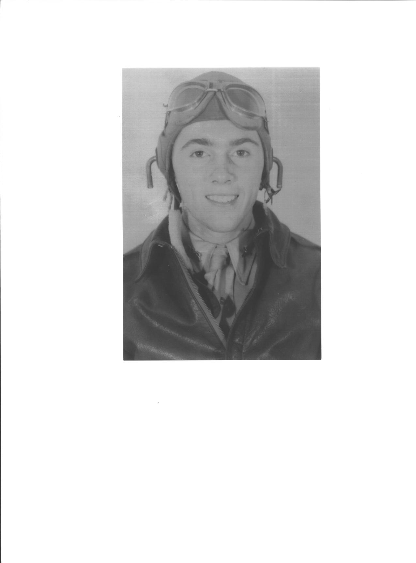

There would be no 25 missions for Patsy Ann III.

Kennie, known by his crew as a straight arrow and a solid leader, decided he would evade the Germans. He would find his way to the Netherlands and contact the Dutch underground.

The copilot worked his way to a clump of trees. He hid until nighttime as the Germans searched on bicycles. It was not going to be an easy trip traveling at night and hiding during the day. Little did he know it would take him ten days. His long-range plan was to contact the resistance. The next step would be to return to England. Lots of obstacles confronted his plan to reach both these goals.

It was cold, wet and fatiguing. He headed west using the button compass from his escape kit. Most nights he buried himself into haystacks. He knew the pain of hunger and stole milk and dug up carrots to keep himself going. His feet were frostbitten. It was tough work.

He crossed the Dutch border the last night of his trek. As was his usual mode of operation, he dug himself into a haystack on a farmer’s field and went to sleep. Not long after, he was awakened by a dog barking. His heart pounded his chest. Fortunately, copilot Kennie was found by two young children Anton Voortman, age 7, and his older sister.

Anton’s father gave him bread and jam. He told Kennie that he must turn him over to the Germans because they could not risk their young children accidentally talking about him. The evading copilot found out that the farmer had previously hidden at least eight Allied airmen in their attic, but the children did not know.

Before Fred Kennie was turned over to the German Army, he gave his wristwatch, his cherished GI issue Elgin, to Anton’s father with great appreciation for what he had done.

The Germans shot villagers who helped down Allied airmen and had done so in the farmer’s village of Eibergen.

The Dutch underground operation could not be put in jeopardy even if it meant turning over an Allied airman.

Lt. Fred Kennie understood.

PATSY ANN III over Munster, Germany on 10 October 1943. 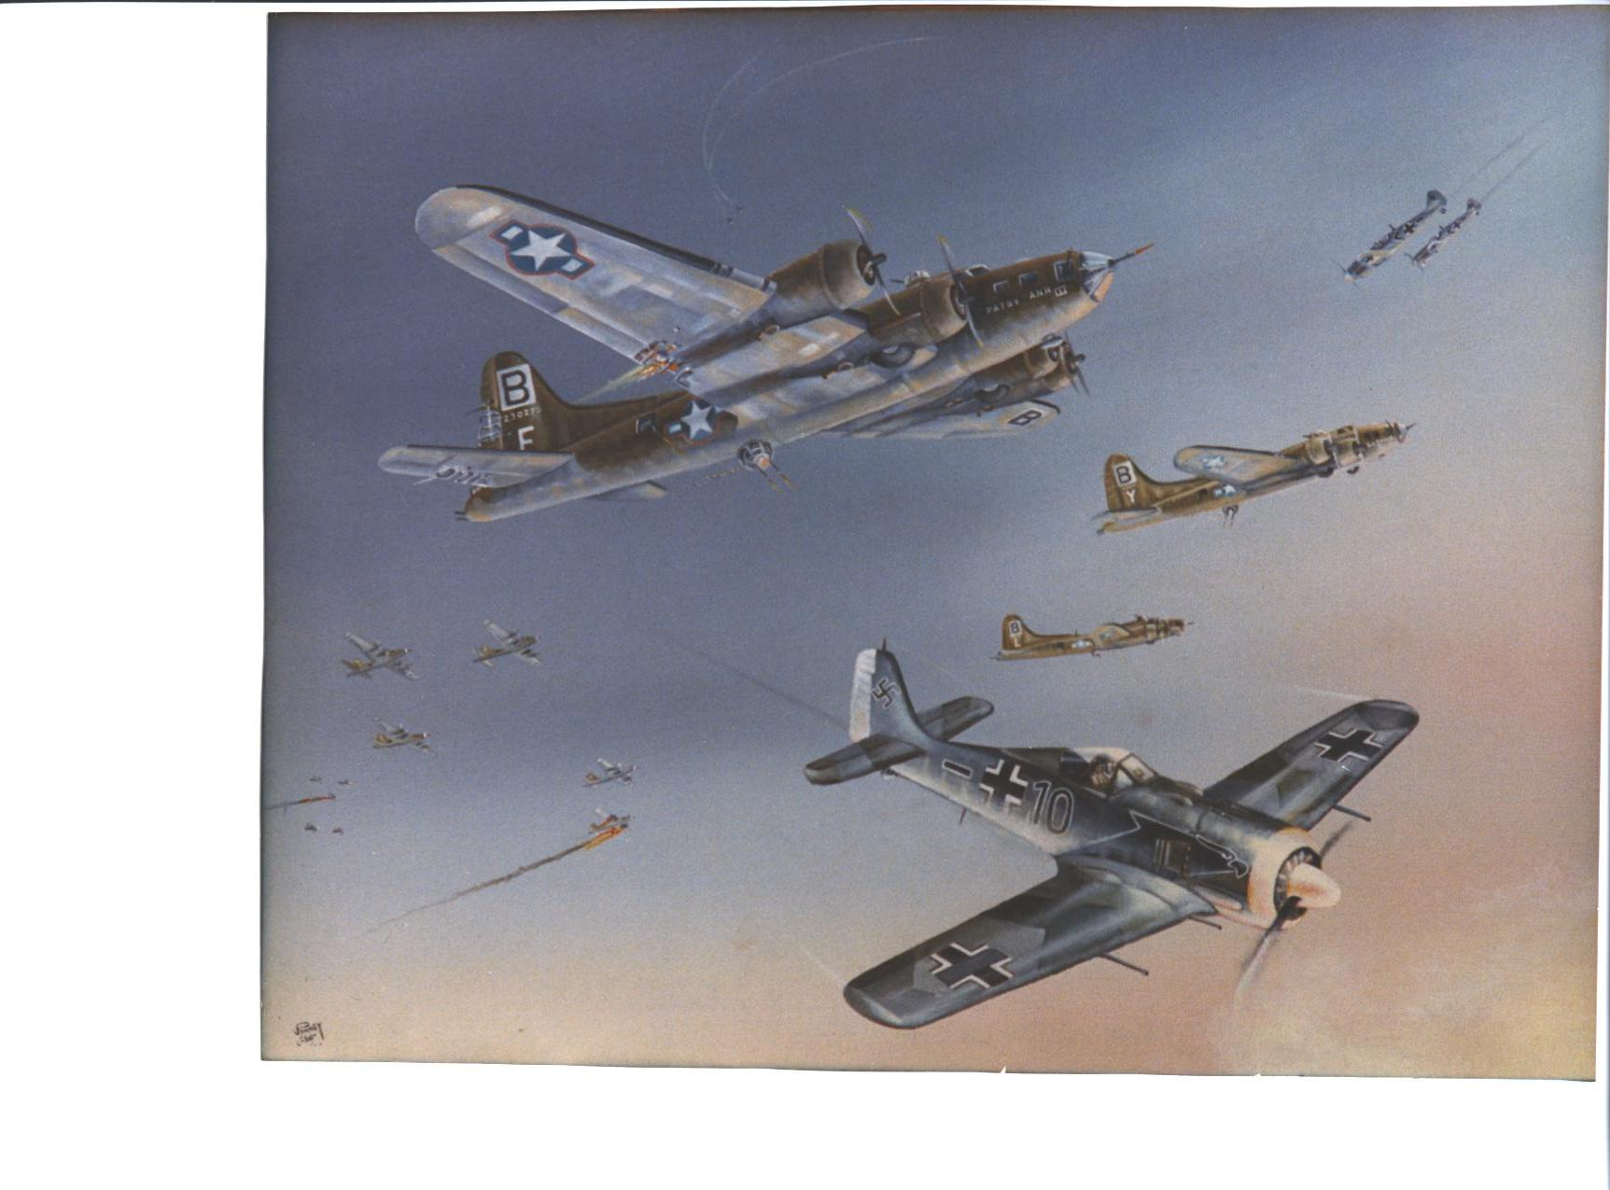
Only bomber Phil Janney ever painted

The copilot preceded his bombardier, Phil Janney, to Stalag I. They remained there until the camp was liberated by Soviet forces in May 1945.

That is another story worth telling.

Fast forward the calendar 49 years. Fred Kennie is still center front on the stage of the Bluebill painting saga. In fact his actions during this 49 year ensured that the history of Patsy Ann III and the Bluebill painting are inexorably linked.

What now follows in the story of Patsy Ann III becomes surreal.

Fred Kennie returns, 49 years later, to Germany and to the town, Emsdetten, nearby where Patsy Ann III had crashed in October 1943. Fred, assisted by Edo van der Laan, a Dutch historian, knew where to look for the grave of Patsy Ann III and where his five aircrew comrades died.

Typical of Kennie’s thoroughness, he went to the farm where parts of Patsy Ann III should remain. He asked the farmer if he could search the farm land for pieces of Patsy Ann III. The farmer responded he had many pieces of the Boeing B-17 and offered them to the copilot.

In the group of rusted metal was a small part with a clear print of a part number. He also gave Fred part of Patsy Ann III’s propeller.

Fred Kennie had touched the past and simultaneously opened a new chapter where Patsy Ann III and her courageous crew could influence the future.

Nearby where Kennie had landed in the soft German plowed field 49 years before, an 84 year old woman gave him handkerchiefs. She had embroidered on the silk from Patsy Ann III’s parachutes.

Kennie’s next stop was Eibergen in Holland to meet with Anton Voortman, the then 7- year old child he had met 49 years before during his quest to evade the Germans and return to England and his flying unit.

Emotions ran high.

Quoting from the San Diego paper, “Anton said his father had worn the Elgin until death. Now Anton had it. “And here it is. Your watch. It is yours again.”

The Elgin, GI issue, wristwatch runs beautifully and Kennie is wearing it still.

Later Fred Kennie sent parts from Patsy Ann III to the surviving crew. Phil Janney received the small part with the part number clearly visible.

A new act in the historical saga surrounding the Bluebill painting begins. Fred Kennie has departed the stage. Phil Janney remains center stage and is now joined by new players.

The new players are retired Boeing employees and founders of the Bluebill Retiree Volunteer organization newly named the Bluebills. It is now late 1995.

Bob Lambert, one of the founders of the Bluebills, receives a telephone call from Phil Janney. Phil was Bob’s childhood mentor in Salt Lake City, a lifetime personal friend and a fellow career U.S. Air Force officer. Bob was a comrade in arms with Phil Janney. Bob always thought Phil looked like Errol Flynn in the 1939 movie about World War I air combat, “Dawn Patrol. As kids, Janney and Lambert had seen “Dawn Patrol” together the Center Theater in Salt Lake City. Both these young Americans loved airplanes and sought adventure. ” Even though they had only kept in touch sporadically over 50 years, there remained and still is a close bond.

Phil was to the point. Since Bob had worked at Boeing, Phil was sending the Patsy Ann III part he received from Kennie to Bob. Phil had a simple request. All Phil wanted to know was where in the B-17 the part fit. “That should be easy for you Boeing types,” Janney said in a half humorous voice.

Bob thought, “How I would have liked to have flown wingman with Janney. He is decisive and unambiguous.”

Phil Janney had thrown a challenge to Bob and to the Bluebills.
He wanted an answer.

Fortunately Bob knew a Boeing retiree who was working with the volunteer team that was rehabbing a B-17. He sent the part to the rehab team. In a couple of days it was returned with photographs and a description of where the part fit. The part came from the upper gun turret. The turret was the one destroyed by the Folke-Wulf 190 attack on Patsy Ann III that afternoon of 10 October 1943.

To complete the answer to Janney, Lambert put the part, a description and photos in a Shadow Box with a caption that read something like, “To the worst bombardier but the best fighter pilot in the U.S. Air Force”. This whole process had been accomplished in a couple of weeks with speed and accuracy that would make the Air Force proud. It was accomplished in the best tradition of Boeing.

The Shadow Box is in a prominate place in the bombardier’s home in Saint George, Utah.

This is not the end of the Patsy Ann III saga and the Bluebill painting. There is more to this improbable set of circumstances that resulted in the Bluebill painting.

A few weeks after the Shadow Box was sent to Janney, the Patsy Ann III’s last bombardier, a couple of the Bluebill founders were searching for the best way for the Boeing Bluebills to recognize achievement. To no great surprise, they concluded that a painting of the Bluebill airplane, and lithographic copies, would be a great motivational tool.

A painting would give the personal touch and reaffirm historical connections. The painting would clearly demonstrate the Boeing Bluebill appreciation for individual or organizational contributions of excellence to the Puget Sound community.

Everyone agreed that Phil Janney, because he was an accomplished artist whose expertise was drawing airplanes, was the first choice. They were convinced that Janney would bring empathy and an awareness of the historical connections. Another plus was that Phil knew about the Boeing Bluebills and their community mission.

The Boeing retirees did not know if Janney’s reluctance, a matter of principle and interest, only to paint fighter aircraft would disqualify the Bluebill. They decided to call and ask the question.

Bob Lambert called the B-17 bombardier, and jet fighter pilot. Lambert jokingly told Janney that under the right circumstances the Bluebill aircraft could have been a fighter during World War I. Bob was not convincing himself let alone Janney.

The old pilot listened patiently. He was quiet for a moment. Phil Janney responded, “Yes he would paint the Bluebill.” He added that he would give the original painting to the Boeing Bluebills, the Boeing Company, because of the mission of the modern day Bluebills.

Lambert knew that this was an honor Phil Janney reserved for very few people. Normally, Phil kept his original painting and sold or gave lithographic copies.

Janney wanted to get started. He asked for every bit of detail he could get on the Bluebill airplane. He was sent a stack of photos, technical data, etc. The conversation ended and his work began.

A few months later the painting was delivered to the Boeing Bluebill office. Janney said he had made several false starts and that he was not satisfied with what he had painted but it was the best he could do. Janney’s dissatisfaction, like all great professionals, was born out of the elusive quest for perfection.

The Bluebill painting was magnificent.

With Janney's permission, the Boeing Bluebills produced 250 full size lithographic copies of the Bluebill painting. These copies were sent to Saint George, Utah, where Phil Janney signed and numbered each copy.

Today these lithographic copies are cherished by people and organizations who have earned them through their contributions of excellence to the Puget Sound community. Their contributions have been recognized by the Boeing Bluebills. Every copy is earned because of organizational or personal sacrifice.

No one can buy a copy of Phil Janney’s Bluebill aircraft painting. They are only given for merit.

The Boeing Bluebills, the Boeing Company and the Puget Sound community owe Phil Janney, Patsy Ann III’s bombardier, a debt of gratitude for his generosity. We thank him for defending American in two wars. We all owe him thanks for unselfishly sharing his great talent.

We thank Fred Kennie for his unwitting role in the Bluebill painting, for allowing his story to be told and for his patriotism and courage in defending our country.

All Americans can never thank enough the noble and courageous men of the 8th Air Force and the aircrew of Patsy Ann III, a Boeing B-17 call sign “Blondie F for Fox.”

Now we know how Patsy Ann III, a World War II Boeing B-17, her unique crew and this painting of this Boeing Bluebill aircraft are tenaciously connected.

Had not Patsy Ann III been shot down on 10 October 1943 this Bluebill painting as we know it would not exist.

Patsy Ann III, call sign Blondie F for Fox, and her ten aircrew live on because of this connection.

There is no end to this story. The memory and spirit of the men who flew Patsy Ann III and the spirit of the Boeing Bluebill volunteers united together will always serve their fellow Americans.

Robert E. (Bob) Lambert

Colonel, United States Air Force (Ret)
and
An original founder of the Boeing Retiree Volunteer Program
. (BLUEBIILLS)

